Project Identification

Project: | Cross Campus
Prepared By: | XCampus
Document Version: | 0.1
Published Date: | Tuesday, October 4th, 2016

Contributors
Name | Title
Karim Boucher | Owner/Developer
Pavle Boraniev | Owner/Lead Developer
Mark Gallant-Wheeler | Owner/Developer
Kazuma Sato | Owner/Developer

Distribution
Name | Title
Anjana Shah | Program Coordinator

Referenced Documents
Version number | Title | Author | Date | Source / Location
1.0 | Helping Old People Easily (HOPE) Project Vision Document. | Team Obiwan | 11/30/10 | https://www.utdallas.edu/~chung/RE/Presentations10F/Team-hope/1%20-%20VisionDoc.pdf

Revision History
Version Number | Revision Date | Summary of Changes | Modified by
[Note: It is recommended that drafts be numbered 0.1 to 0.9, and that the first approved version be numbered 1.0. Thereafter, new version numbers will depend upon changes: 1.01, 1.1, etc for minor updates, 2.0, 3.0 etc for major changes.]

TABLE OF CONTENTS
1. Business Context Diagram 3
1.1 Requirement Scope Area 3
1.2 External Entity 3
1.3 Information Flows 3
2. Requirements Scope Statements 3
3. High Level Business Requirements Sign-Off 4

- Business Context Diagram
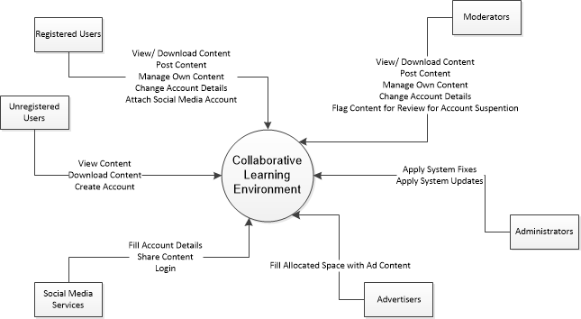

Requirement Scope Area | Description
Collaborative Learning Environment | A system on which students can access, and share class notes. Also a maintained service for offering tutoring services. A marketplace for students in both upper and lower years to buy, trade and sell textbooks.

External Entity | Description
Non-Registered User | User with only viewing privileges
Registered User | A registered user who has viewing, posting and editing privileges
Moderator | A registered user who can flag content, and suspend other users.
Administrator | A super user
Advertisers | A company who can post advertisements
Social Media Services | Services which users can use to share content and generate user data for ease of registration

Information Flows | Description
View Content | Non-Registered and Registered Users can view posted content
Post/Manage Own Posted Content | Registered User can manage either own content
Flag Inappropriate Content | Screening Content put up by Registered Users
Upgrade/update system | Admins can perform system fixes and updates
Post advertisements | Advertisers fill allocated space with ad content
Sharing content | Share content onto social media
- Requirements Scope Statements
HLR# | Description | Priority
 | User shall be able to upload notes | High
 | User shall be able to download notes | High
 | User shall be able to access tutoring for a desired course | High
HLR04 | User shall be able to provide tutoring for a desired course | High
HLR05 | User shall be able to advertise available textbooks | High
HLR06 | User shall be able to view textbook advertisements | High

- High Level Business Requirements Sign-Off
The undersigned acknowledge their agreement with the contents of Version 0.1 of the High-Level Requirements document for Cross Campus.

Following approval of this document, requirements changes will be governed by the project’s change management process, including impact analysis and appropriate reviews and approvals, under the general control of the Project Plan and according to company policy. Approved Change Request Documents, if present, will be attached to this Requirements Document as updates.

Name | Project Role and  Functional Area | Date Signed
Mark Gallant-Wheeler | Owner/Developer | October, 4th 2016
Pavle Boraniev | Owner/Lead Developer | October, 4th 2016
Karim Boucher | Owner/Developer | October, 4th 2016
Kazuma Sato | Owner/Developer | October, 4th 2016

* Note: physical signatures are not required. Email approvals are acceptable and should be appended to project documents.

